# AutoWeb

miniGuide

**AutoWeb is the best website Enter your dream. That means you can choose the vehicles that are essential to your life here. Let’s see how to use this website for choose your dream.Let’s see mini user guide,**

1. **Home Background- That is main in this website. All the functions locate in this background. You can choose any on this background.**
2. **A yellow emoji with tears on it

   AI-generated content may be incorrect.Option Bar- All the options locate in this tab.**
3. **A yellow emoji with tears on it

   AI-generated content may be incorrect.Like Button- You can like this website If it touches your heart .**
4. **Home- It is need on other page for come back to the home page.**
5. **Prices- You can use this tab for see the price ranges of your dream automobile.**
6. **Options- You can see all the fuctions in this website.**
7. **Brands- You can choose your vehicle brand before choose the vehicle.**
8. **Miniguide- You can download this user guide on this webpage.**



1. **More info- You can see the version ,motto and etc. You can check more updates on this webpage.**
2. **Dream button- You can see all the specifications, videos, photos and etc. You can download fantastic videos on this web pages.**

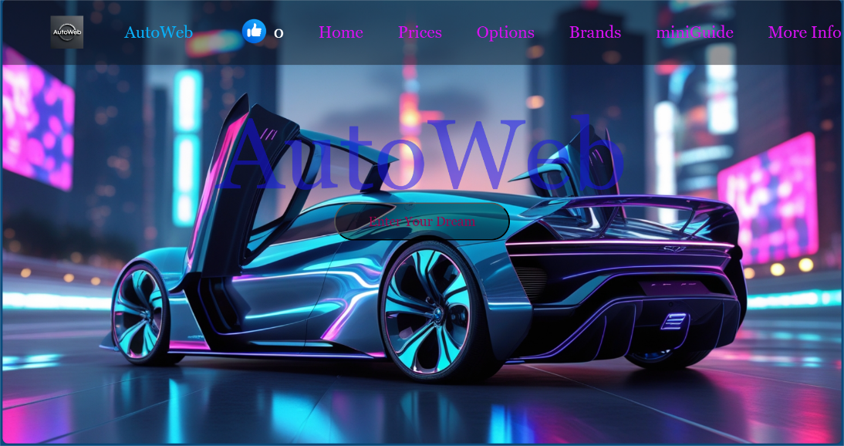**Home background**

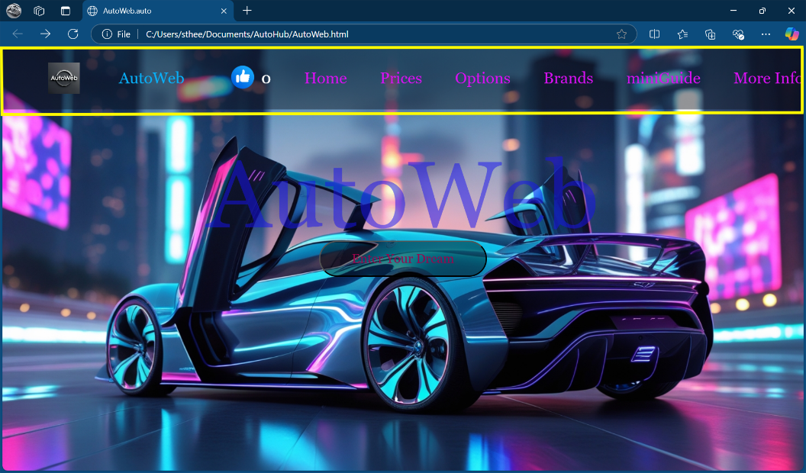**Option Bar**

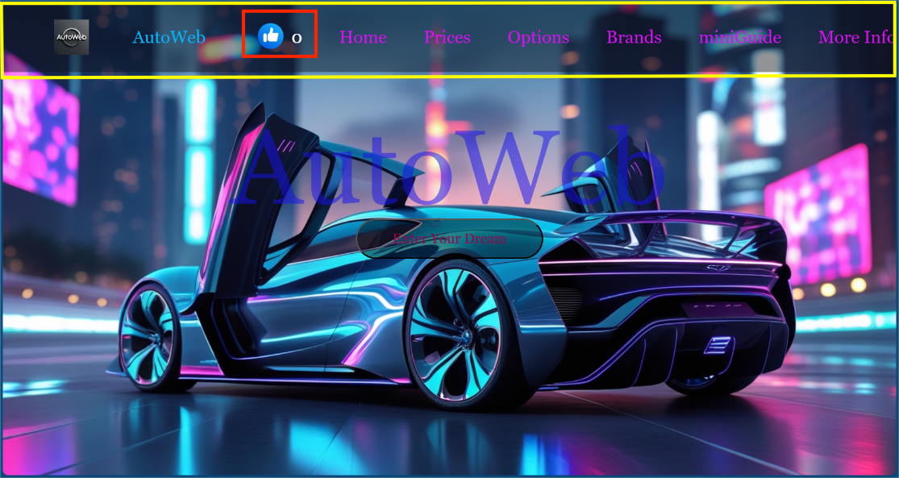**Like Button**



